TEAM MEMBERS
RAMYA B (TEAM LEADER)
SHAHIN S
PRIYADHARSHINI K
JANANI G

ABSTRACT
This project focuses on automating employee data management using the ServiceNow platform. Organizations typically manage a large amount of employee information such as employee name, employee ID, department, designation, and contact details. Managing this information manually can lead to errors, duplication of data, and time-consuming administrative processes. ServiceNow provides powerful automation capabilities through features such as Import Sets, Transform Maps, and data relationships that allow organizations to efficiently manage employee records. In this project, employee data is imported from external sources such as Excel files and automatically transformed into the ServiceNow employee table. The system reduces manual effort, improves data accuracy, and ensures consistency of employee information across the organization. Automation also enables faster processing of employee records and simplifies the management of organizational data. This project demonstrates how ServiceNow can be effectively used to automate employee data management in modern organizations.
INTRODUCTION
Employee data management is an essential function in every organization. Human Resource (HR) departments manage a large volume of employee information including personal details, department assignments, job roles, and reporting structures. When this information is handled manually, it can lead to errors, inefficiencies, and delays. Modern organizations rely on automation tools to simplify and streamline these processes. ServiceNow is a cloud-based platform that allows organizations to automate workflows and manage enterprise data efficiently. It provides tools such as Import Sets, Transform Maps, and Flow Designer that help automate data import and management tasks. This project demonstrates how employee data can be automatically imported into ServiceNow from external sources such as Excel files. The system reduces manual work and ensures accurate employee records. It also supports relationships between tables such as employees, departments, and managers, making organizational data management easier and more efficient
PROBLEM STATEMENT
Many organizations still rely on manual entry of employee data into management systems. Manual data entry is time-consuming and may result in incorrect or incomplete information. Some of the common problems include:
Duplicate employee records Incorrect department assignments
Time-consuming data entry processes Lack of centralized
employee data management Difficulty in maintaining consistent records
These issues reduce the efficiency of HR operations and may affect organizational productivity. Therefore, an automic

SCREEN LAYOUT
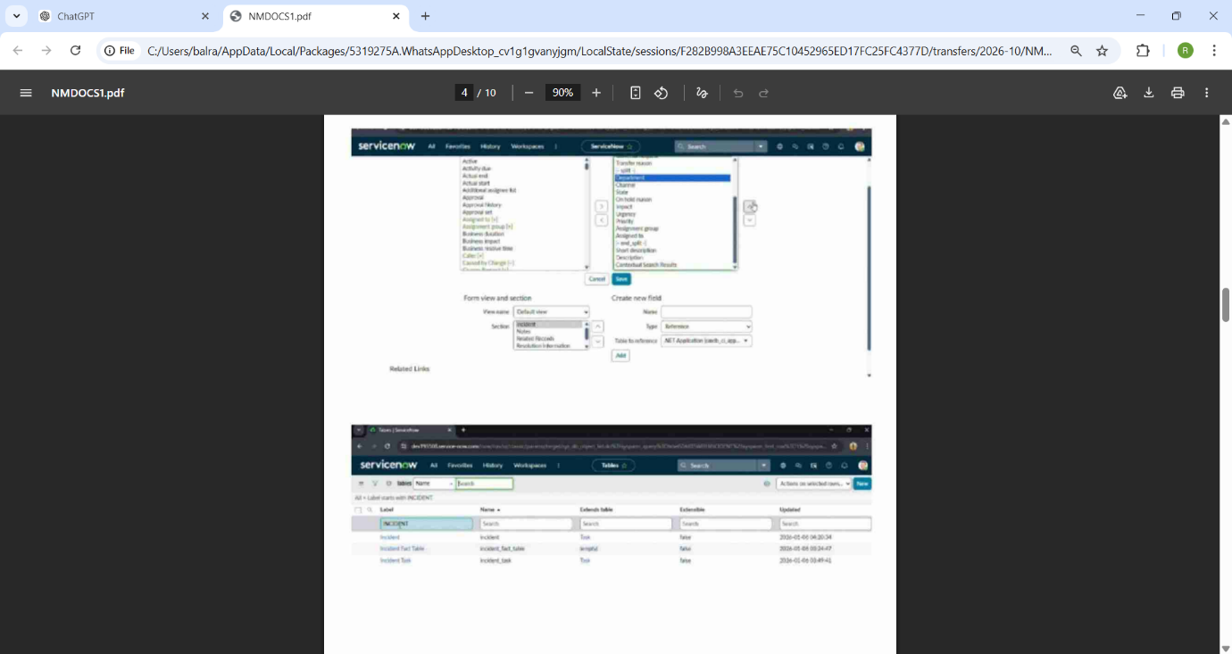
OBJECTIVES
The main objectives of this project are: To automate the process of importing employee data into ServiceNow To reduce manual effort in employee data entry To ensure accurate and consistent employee records To establish relationships between employee and department tables To improve overall HR data management efficiency
SCOPE OF THE PROJECT
The scope of this project is limited to employee data management using the ServiceNow platform. The system focuses on importing employee information from external files and storing it in ServiceNow tables. The project includes the following functionalities: Creating employee tables in ServiceNow Importing employee data from external files such as Excel Transforming imported data using Transform Maps Linking related tables using dot walking Automating updates and notifications However, the project does not include advanced HR management features such as payroll processing, attendance management, recruitment systems, or performance evaluation modules.
PROJECT PHASE (7 Steps)
The development of this project follows seven important phases of the system development process. 1. Identification Phase This phase identifies the problem in the existing system. Many organizations manage employee data manually, which leads to errors, duplication, and inefficiencies. The need for an automated employee data management system using ServiceNow is identified in this stage.
2. Requirement Analysis In this phase, system requirements are analyzed. The functionalities required for the system such as employee data import, data transformation, table relationships, and automation are defined. The roles of users and system features are also identified
3. System Design During this phase, the system architecture is designed. Database tables such as the Employee table are created, and relationships between tables such as departments and managers are planned.
4. Development Phase In this phase, the actual development of the system takes place. ServiceNow components such as Import Sets, Transform Maps, and Flow Designer are configured to build the automate dsystem
5. Testing Phase The system is tested to ensure that employee data is imported correctly and that the automation works properly. Errors are identified and corrected during this phase.
6. Implementation Phase After successful testing, the system is implemented in the ServiceNow environment. Employee data imported and stored in the employee table.
7. Maintenance Phase is After implementation, the system is monitored and maintained. Updates, improvements, and bug fixes are performed when necessary to ensure the system continues to work efficiently.

LITERATURE REVIEW
Enterprise platforms such as ServiceNow, SAP, and Oracle are widely used for managing organizational data and business processes. ServiceNow has gained popularity due to its cloudbased architecture, flexibility, and powerful automation capabilities. Research and industry studies show that automation in data management improves data accuracy, reduces operational costs, and increases efficiency. Automated systems minimize manual errors and help organizations manage large datasets effectively. ServiceNow provides features such as Import Sets and Transform Maps that allow organizations to import and transform large amounts of data from external sources. These features are widely used
TOOLS & TECHNOLOGIES
Platform Used ServiceNow Technologies used in this project include: ServiceNow Instance Import Sets Transform Maps Employee Database Tables Dot Walking Flow Designer for automation These technologies enable the efficient import, transformation, and management of employee data within the ServiceNow platform.
MODULES OF THE SYSTEM
The project consists of several modules that handle different system functions. 1. Employee Data Import Module This module is responsible for uploading employee data into ServiceNow using Import Sets.
2. Data Transformation Module Transform Maps are used to convert imported data fields into the correct fields in the employee table.
3. Employee Record Management Module This module manages and stores employee information in the ServiceNow employee table.
4. Relationship Mapping Module Dot walking is used to establish relationships between employee records and related tables such as department and manager tables.
5. Automation Module Flow Designer or workflows automatically update records when new employee data is imported into the system.
IMPLEMENTATION
The implementation process involves configuring ServiceNow to automate employee data management. Steps involved in the implementation process:
1. Create a custom Employee table in ServiceNow.
2. Define fields such as employee ID, name, department, designation, and contact details.
3. Prepare employee data in Excel format.
4. Create an Import Set table in ServiceNow.
5. Upload the employee data file into the Import Set table.
6. Create a Transform Map to map the imported fields with employee table fields.
7. Run the transform process to import data into the employee table.
8. Verify imported employee records for accuracy.
9. Use dot walking to connect related tables such as employees, departments, and managers.
10. Use Flow Designer to automate updates and notifications.
ADVANTAGES
The automated employee data management system developed using ServiceNow provides several benefits. Reduced Manual Work Automation reduces the need for manual data entry and saves time for HR staff.
Improved Data Accuracy The system minimizes human errors and ensures that employee data is correctly stored.
Faster Data Processing Large amounts of employee data can be processed quickly using automated import features.
Better Data Consistency Transform Maps ensure that data is stored in a consistent format across tables.
Centralized Data Management
All employee records are stored in a single system, making them easier to manage.
Efficient Data Relationships Dot walking allows easy navigation between related tables such as employee and department.
Scalability The system can handle increasing employee data as the organization grows.
FUTURE ENHANCEMENT
Possible future enhancements include:
Integration with payroll management systems Employee attendance and leave management modules Employee performance evaluation systems Self-service portals for employees to update their information Dashboard and reporting tools for HR analytics Integration with other enterprise systems for better data sharing These enhancements can further improve HR operations and provide a more comprehensive employee management solution
CONCLUSION
The Employee Data Management Automation using ServiceNow project demonstrates how enterprise platforms can simplify and automate data management processes. By using tools such as Import Sets, Transform Maps, and Flow Designer, employee data can be efficiently imported, transformed, and stored within the ServiceNow environment. The system reduces manual data entry, improves data accuracy, and ensures consistent employee records across the organization.
Automation also enables HR departments to manage large volumes of employee information more effectively. Overall, this project highlights the importance of automation in modern organizations and shows how ServiceNow can improve data management and operational efficiency. The solution provides a scalable and reliable system for managing employee records and can be further enhanced with additional HR features in the future.

